**Vacation Guide System**

Course: DBS

Section: ZDD

Group: 10

Members: Yu Hsin Fang, Xiayue Zhao, Maria Patricia Espinoza Bueno

**ERD:**

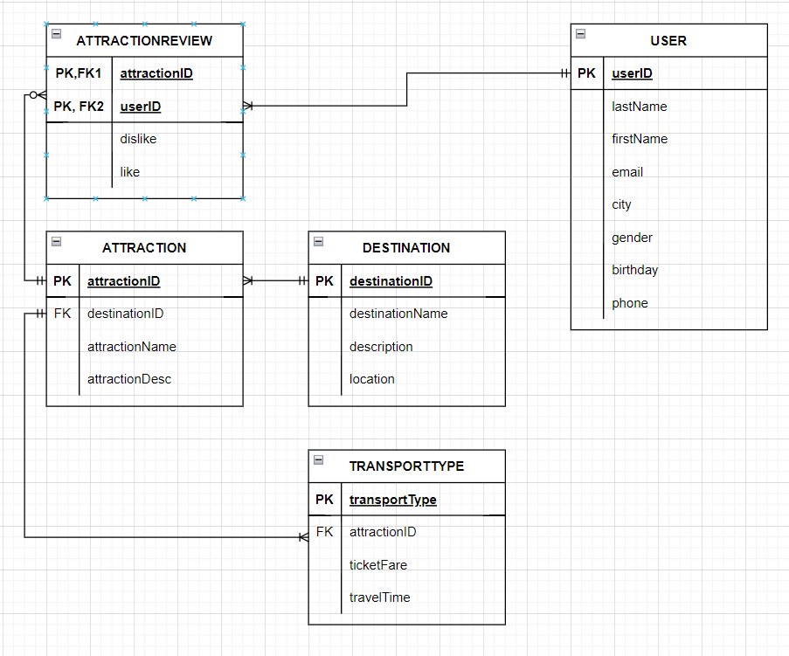

**Data Dictionary:**

TABLE: **Users**

|  |  |  |  |  |  |  |  |
| --- | --- | --- | --- | --- | --- | --- | --- |
| **Column** | **Data Type** | **Size, Precision** | **PK/FK** | **Required** | **Range** | **Sample Data** | **Notes** |
| userID | String | 4 | PK | Y | Null | “hi123” |  |
| lastName | String | 30 |  | Y | Null | “McKenzie” |  |
| firstName | String | 20 |  | Y | Null | “Bob” |  |
| email | String | 35 |  | Y | Null | [123@gmail.com](mailto:123@gmail.com) |  |
| city | String | 30 |  | N | Null | “Toronto” |  |
| gender | string | 1 |  | N | Null | “F” |  |
| birthday | Date | 10 |  | Y | Null | 22/01/01 | YY/MM/DD |
| phone | Number | 11 |  | Y | 2000000000-9999999999 | 9055551212 | North American |

TABLE: **AttractionReview**

|  |  |  |  |  |  |  |  |
| --- | --- | --- | --- | --- | --- | --- | --- |
| **Column** | **Data Type** | **Size, Precision** | **PK/FK** | **Required** | **Range** | **Sample Data** | **Notes** |
| attractionID | String | 5 | PK/FK | Y | A1-A9999 | “A1234” |  |
| userID | String | 4 | PK/FK | Y | 0001-9999 | “0001” |  |
| dislikes | Number | 1 |  | N | 1-99999999 | 1298 |  |
| likes | Number | 1 |  | N | 1-99999999 | 308119 |  |

TABLE: **Attraction**

|  |  |  |  |  |  |  |  |
| --- | --- | --- | --- | --- | --- | --- | --- |
| **Column** | **Data Type** | **Size, Precision** | **PK/FK** | **Required** | **Range** | **Sample Data** | **Notes** |
| attractionID | String | 5 | PK | Y | A1-A9999 | “A1234” |  |
| destinationID | String | 2 | FK | Y | Null | “ON” |  |
| attractionName | String | 100 |  | Y | Null | “Casa Loma” |  |
| attractionDesc | String | 1000 |  | Y | Null | “Casa Loma is a Gothic Revival castle-style mansion and garden in midtown Toronto, Ontario, Canada, that is now a historic house museum and landmark.” |  |

ABLE: **TransportType**

|  |  |  |  |  |  |  |  |
| --- | --- | --- | --- | --- | --- | --- | --- |
| **Column** | **Data Type** | **Size, Precision** | **PK/FK** | **Required** | **Range** | **Sample Data** | **Notes** |
| transportType | String | 10 | PK | Y | Null | “Airplane” |  |
| attractionID | String | 5 | FK | Y | A1-A9999 | “A1234” |  |
| ticketFare | Number | 5 |  | Y | 1-9999 | 113 | Currency: Canadian dollar (code: CAD) |
| travelTime | Datetime | 18 |  | Y | 1900-01-01 through 2079-06-06 | 2023-10-23  14:15:00 | Format: YYYY-MM-DD hh:mm:ss |

TABLE: **Destination**

|  |  |  |  |  |  |  |  |
| --- | --- | --- | --- | --- | --- | --- | --- |
| **Column** | **Data Type** | **Size, Precision** | **PK/FK** | **Required** | **Range** | **Sample Data** | **Notes** |
| DestinationID | String | 2 | PK/ FK2 | Y | Null | “ON” |  |
| DestinationName | String | 100 |  | Y | Null | “Ontario” |  |
| description | String | 1000 |  | Y | Null | “Canada's second largest province, covering more than 1 million square kilometres (415,000 square miles) - an area larger than France and Spain combined.” |  |
| location | String | 30 |  | Y | Null | Central Canada |  |